AIM
To find the maximum profit that can be obtained by selecting items with given weights and values without exceeding the given knapsack capacity using Dynamic Programming.
ALGORITHM
- Read the weights, values, and capacity.
- Create a DP table of size (n+1) × (capacity+1).
- For each item, check whether its weight is less than or equal to the current capacity.
- If it fits, choose the maximum of:
  - Including the item.
  - Excluding the item.
- If it does not fit, exclude the item.
- Return the value in the last cell of the DP table. 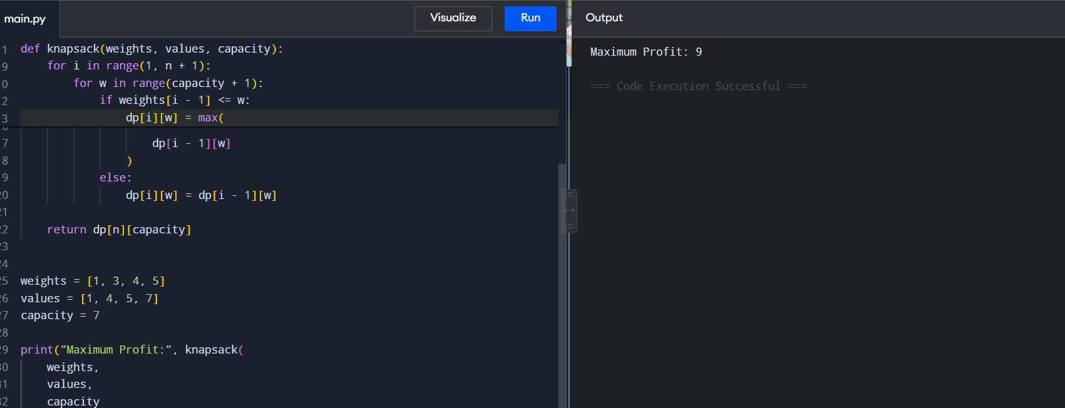
RESULT
Maximum Profit: 9
Thus, the maximum profit obtained is 9.

2. Travelling Salesperson Problem — Dynamic Programming
AIM
To find the minimum cost tour for a salesperson visiting every city exactly once and returning to the starting city using Dynamic Programming.
ALGORITHM
- Represent the cities using a cost matrix.
- Start from city 0.
- Use a bitmask to keep track of visited cities.
- Recursively visit every unvisited city.
- When all cities are visited, return the cost of going back to city 0.
- Store already calculated results using memoization.
- Select the minimum-cost route. 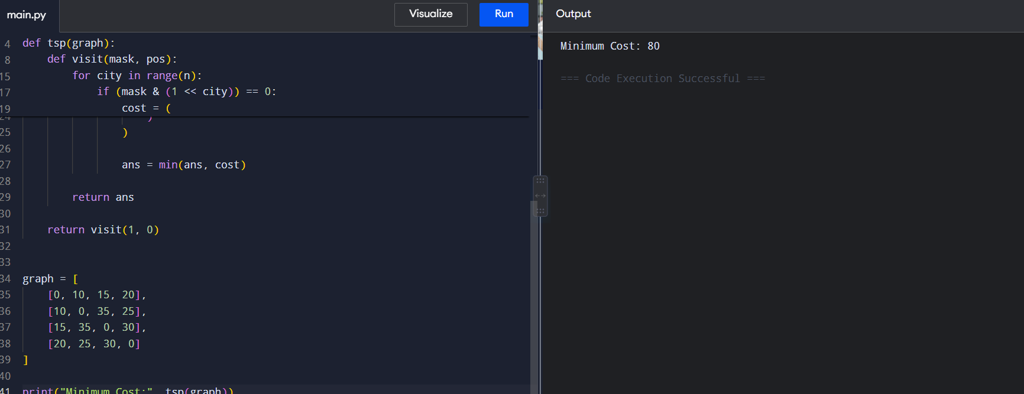
RESULT
Minimum Cost: 80
Thus, the minimum travelling cost is 80.

3. Optimal Binary Search Tree — OBST
AIM
To construct an Optimal Binary Search Tree with minimum search cost based on the frequencies of the keys.
ALGORITHM
- Read the keys and their frequencies.
- Create a cost table.
- Initialize the cost of a single key with its frequency.
- Consider chains of increasing length.
- Calculate the total frequency of each range.
- Try every key as the root.
- Calculate the left and right subtree costs.
- Select the minimum cost.
- Return the cost of the complete tree. 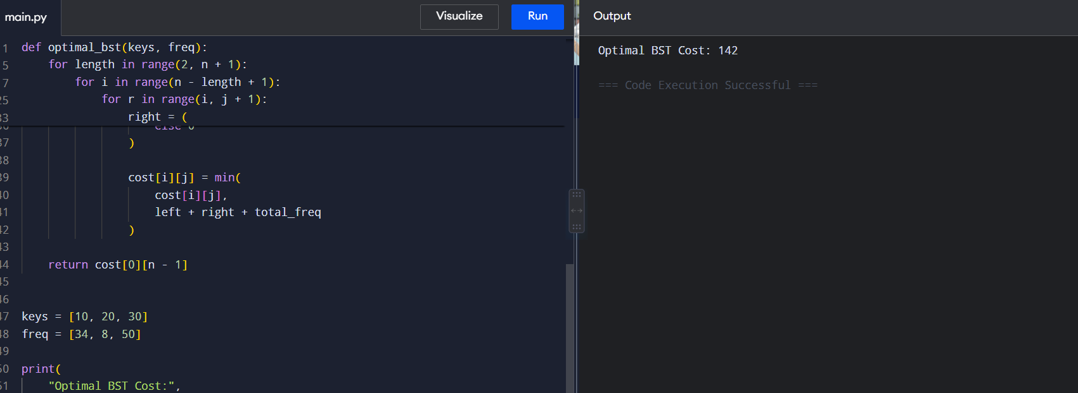
RESULT
Optimal BST Cost: 142
Thus, the minimum cost of the Optimal Binary Search Tree is 142.

4. 0/1 Knapsack Problem
AIM
To solve the 0/1 Knapsack problem using Dynamic Programming and determine the maximum possible profit within the given capacity.
ALGORITHM
- Read the weights, values, and knapsack capacity.
- Create a DP table.
- Consider each item one by one.
- If an item fits into the current capacity, calculate both inclusion and exclusion cases.
- Store the maximum value.
- If it does not fit, retain the previous value.
- Return the maximum profit. 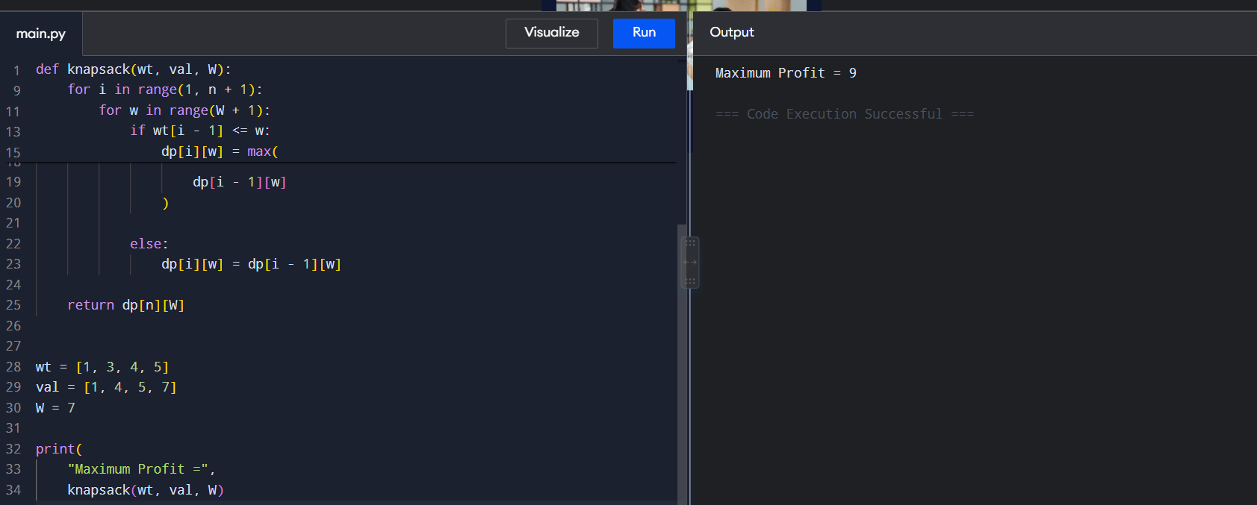
RESULT
Maximum Profit = 9
Thus, the maximum profit is 9.

5. 0/1 Knapsack Using Memoization
AIM
To solve the 0/1 Knapsack problem using the Memoization technique of Dynamic Programming.
ALGORITHM
- Read weights, values, and capacity.
- Create a memoization table initialized with -1.
- Check the base case where capacity or number of items is zero.
- If the result is already stored, return it.
- If the item fits, calculate both inclusion and exclusion cases.
- Store the maximum result in the memo table.
- Return the final maximum profit. 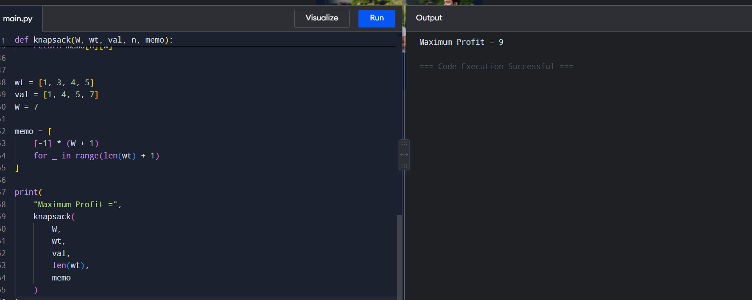
RESULT
Maximum Profit = 9
Thus, the maximum profit obtained using memoization is 9.

6. Subset Sum Problem
AIM
To determine whether a subset of the given set exists whose sum is equal to the specified target using Dynamic Programming.
ALGORITHM
- Read the array and target sum.
- Create a Boolean DP table.
- Set dp[i][0] = True because an empty subset has sum zero.
- For every element, check whether it can be included.
- Store whether the target sum is possible.
- Return the final Boolean value. 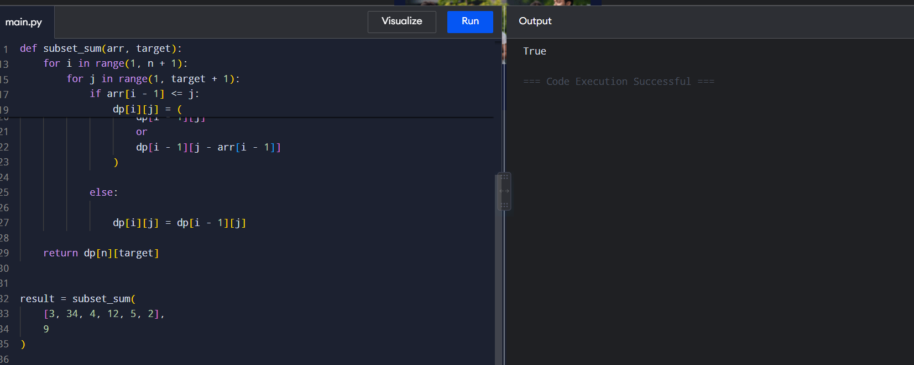
RESULT
True
Thus, a subset with sum 9 exists.

7. Travelling Salesperson Problem — DP Version
AIM
To find the minimum cost required to visit all cities exactly once and return to the starting city using Dynamic Programming with memoization.
ALGORITHM
- Store the distances between cities in a graph.
- Represent visited cities using a bitmask.
- Start from city 0.
- Recursively visit every unvisited city.
- When all cities are visited, return to city 0.
- Store previously calculated states using memoization.
- Find and display the minimum cost. 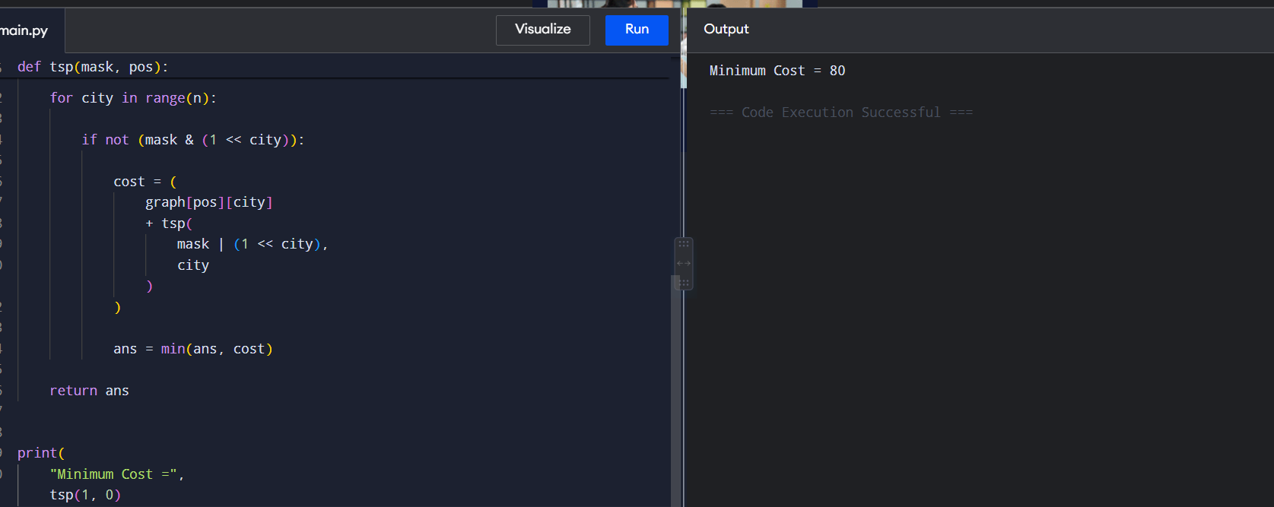
RESULT
Minimum Cost = 80
Thus, the minimum tour cost is 80.

8. Travelling Salesperson Using DP Table
AIM
To solve the Travelling Salesperson Problem using a Dynamic Programming table and bitmasking.
ALGORITHM
- Create a DP table with 2^n rows and n columns.
- Initialize the starting city with cost zero.
- For each visited-city mask, consider every current city.
- Visit each unvisited city.
- Update the corresponding DP table entry with the minimum cost.
- After visiting all cities, add the cost of returning to the starting city.
- Select the minimum total cost. 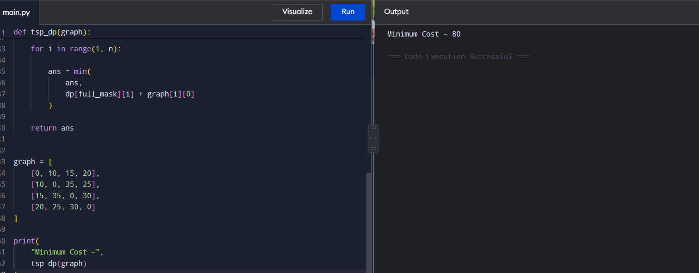
RESULT
Minimum Cost = 80
Thus, the minimum travelling cost is 80.

9. Optimal Binary Search Tree — OBST
AIM
To find the minimum search cost of an Optimal Binary Search Tree using Dynamic Programming.
ALGORITHM
- Read the frequencies of the keys.
- Create a cost table.
- Initialize the cost of individual keys.
- Consider different lengths of key sequences.
- Calculate the total frequency of each sequence.
- Try each key as the root.
- Calculate the left and right subtree costs.
- Select the minimum cost.
- Return the minimum cost of the complete tree. 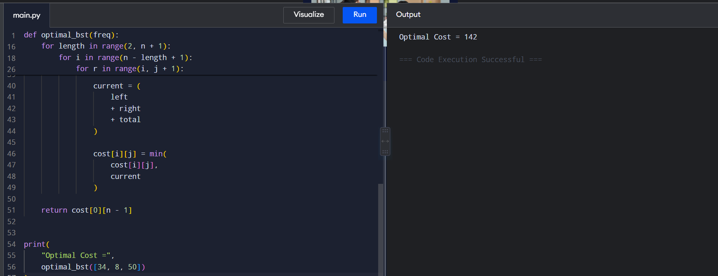
RESULT
Optimal Cost = 142
Thus, the Optimal BST has a minimum cost of 142.

10. Matrix Chain Multiplication
AIM
To determine the minimum number of scalar multiplications required to multiply a sequence of matrices using Dynamic Programming.
ALGORITHM
- Read the dimensions of the matrices.
- Create a DP table.
- Consider chains of increasing length.
- Try every possible position to split the matrix chain.
- Calculate the multiplication cost for each split.
- Store the minimum cost.
- Return the minimum multiplication count. 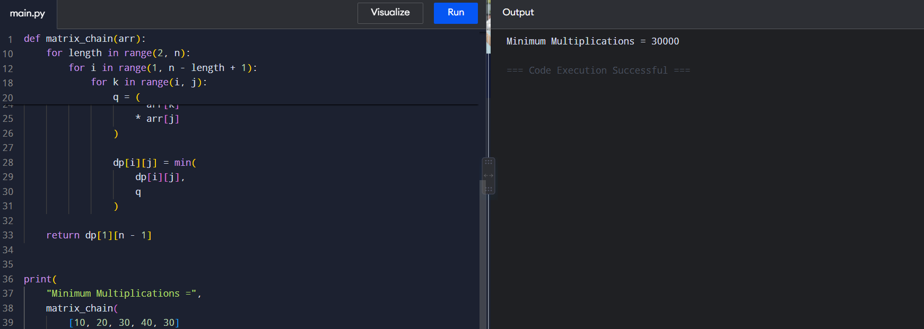
RESULT
Minimum Multiplications = 30000
Thus, the minimum number of scalar multiplications is 30000.

